Seminar Report

Visibility Graphs and Applications


SUBMITTED BY :
Shravan kumar Singh (16CS60R79)

UNDER THE GUIDANCE OF :
Prof. Sudebkumar Prashant Pal
Department of Computer Science & Engineering
I.I.T Kharagpur

Table of Content

- Introduction
- Why visibility Graphs?
- Outline
- Finding Visibility Graph for Polygon(with holes) in O(n²logn) time
- Finding Visibility Graph for Polygon(with holes) in O(n²) time
1) Notations
2) Design
3) Algorithm
- Finding Visibility Graph for Polygon(without holes) in O(E) time
  - Definitions
  - Design
  - Steps to construct visibility Graph
  - Complexity
- Conclusion
- Reference

Introduction

Visibility graph is a widely applied technique to find possible paths in a 2 dimensional world. It is commonly used in artificial intelligence applications. Visibility graph structure of a set of polygons is an undirected graph. Vertices of the visibility graph are the vertices of polygons. Edge set of the visibility graph is a subset of all possible edges between these vertices that does not intersect edges of given polygons in exactly one point, such that, the edges that does not intersect any polygon edges, plus edges of polygons. With this graph, it is possible to find a shortest path between any of the two vertices, using a graph search algorithim. The topic is how to construct the visibility graph of a polygon with and without holes. Here is an example of visibility graph drawn from a polygon(each vertex in visibility graph is represented with a subscript)
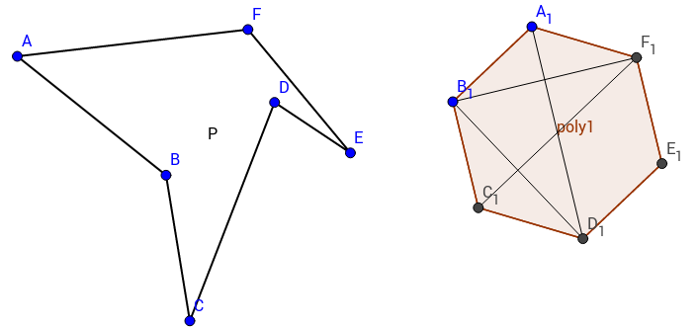

Why visibility Graphs?

Problem-We are given a set of n disjoint polygonal obstacles in the plane,and two points s and t that lie outside of the obstacles .The problem is to determine the shortest path from s to t that avoids the interiors of the obstacles .
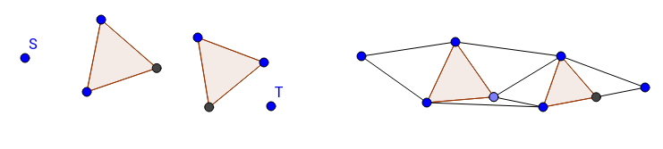
Claim – The shortest path between any two points that avoids a set of polygonal obstacles is a polygonal curve, whose vertices are either vertices of the obstacles or the points s and t.
Then shortest path can be computed by first computing the visibility graph and labeling each edge with its Euclidean distance, and then computing the shortest path by, say, Dijkstra's algorithm.

Outline

In the rest of this report, I first introduce the algorithm of ‘Constructing Visibility Graph in O(n2logn) time.’ After that, I introduce algorithm(Hershberger) that accomplishes the same task for polygon without holes in O(E), where E is the total number of edges in visibility graph. At last I present algorithm by Welzl that computes visibility graph of a polygon with holes in O(n2).

Finding Visibility Graph for Polygon(with holes) in O(n2logn) time

To do this we perform a rotational plane sweep around every vertex in S(vertex set). In the rotational sweep, we consider a vertex w visible from v if a ray cast from v in the direction of w doesn’t intersect the interior of an obstacle before reaching w . So we iterate through every vertex of the polygonal obstacles and find every visible other vertices. To generate these lines, we have to iterate through every vertex v in V . Because we will check every line in angular order so we need to sort the vertices in polar angles, which takes O(nlogn) time. Finding the visible vertices for each of n vertices takes O(n² logn).

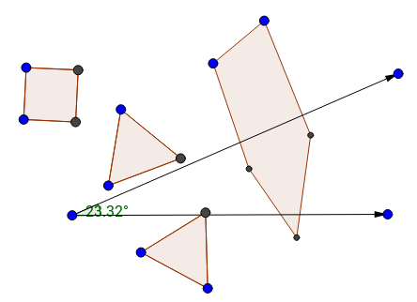
Ray emanating from v rotating in plane:

We call L as the order of rotation for S. The merging of 2n sorted lists having n elements in each list takes O( n² log n) time using pair-wise merging. This can be improved to O( n² ) by computing L directly from S without going through merging, using duality of lines and points.

Finding Visibility Graph for Polygon(with holes) in O(n2) time

Notations

S the set of n non-intersecting closed line segments in the plane.
VS the set of endpoints of the line segments in S
GS the visibility graph of S (VS are the nodes in the graph and ES is the edge list)
ES the list edges ∈ GS
d(v, v’), v,v’ ∈ V the direction determined by the directed line passing from v to v’

Design

For the sake of simplicity, we assume that
1) no three points in VS are collinear,
2) no lines that passes through points in VSare parallel, and
3) no two points have the same y value.
These situations can be handled without losing the O(n2) time complexity.
So there can be C(2n, 2) distinct directions since n line segments have 2n endpoints in total.
DS a sorted array of directions (sorted with respect to their slopes ranging from -∞ to ∞(we will shortly see how we find directions). One direction can only be expressed with either d(v, v’) or d(v’, v)).
For the initial state the the downward line that emanates from v will intersect the line at infinity for purpose of ease.Now, we rotate the direction from downwards to upwards (that is, slopes from -∞ to +∞), one by one taking one direction from DS . For d = d(v, v’) there can be four cases :
Same segment: If A and B are endpoints of the same segment, then they are visible, and we can add the edge (A, B) to the visibility graph.
Invisible: Consider the distance from A to B. Then find the distance between A and the intersection point of ray that is fired from A to the previous visible segment. If distance of AB is bigger then B is not visible from A, and so not added in visibility graph.
Segment entry: When sweep is just about to enter this segment. If we are entering the segment, then we set new visiblily edge from A to B for this segment.
Segment exit: If we are just leaving segment, then the ray path will need to shoot out and find the next segment that it hits because that will be new visible segment for A. Normally this would require some searching, if we are not maitaining sorted angular order (this is one of the reasons this algorithm performs better.), so we can claim that the answer is available to us in O(1) time.

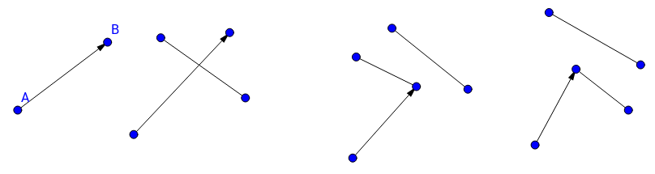
Visible Not visible Entry Exit

Now what we do is, going through all the directions in DS, and in each occurrence of an event (the four cases), we update R accordingly, find the visible vertices and insert them to ES.
The order of rotation for the segments can be constructed in O( n² ) time using duality of lines and points. When we map every point v ∈ VS to the dual space, we will obtain an arrangement of lines AS. Now every intersection in AS corresponds to a direction d in DS. We can generate an acyclic digraph G(AS) from this AS with the following constraints:
-for each arc from node d1 to node d2 in G(AS), d1 is to the right of d2,
-d1 and d2 lie on a common line and no other intersection is between them on this line.

Theorem: Let D denote the set of all segments between any two endpoints of n line-segments in S. The order of rotation for the segments in D can be constructed in O(n² ) time.
Proof Idea: We use the concept of duality for this proof. Let A be the arrangement of 2n lines which is the dual of endpoints v₁ , v₂ , . . . , v_{2n} of polygon. So every endpoint v_{i} = ( a_{i} , b_{i} ) is mapped to a line T_{i} with equation y = a_{i} x + b_{i} . We know that every intersection point w_{ij}= (a_{ij} , b _{ij} ) in A of two lines T_{i} and T_{j} corresponds to the line y = −a _{ij} x + b _{ij} passing through v _{i} and v _{j} . Hence, the direction of every segment in D with slope k corresponds to an intersection in A with x-coordinate −k . Now we take all intersection points on T_{i} in the order along T_{i} to get ordering of directions. It can be seen that this order is same as the angular order around v _{i} of all segments in D with endpoint v _{i} . Given this slope ordering, we can simply test which primal points lie to the left of p (that is, have a smaller x-coordinate in the primal plane), and separate them from the points that lie to the right of p (having a larger x-coordinate). We partition the vertices into two sorted sequences, and then concatenate these two sequences, with the points on the right side first, and the points on the left side later. The resulting is an angular sequence starting with the angle −90 degrees and proceeding up to +270 degrees. Once we get this angular orderings in O(n) time , it has been shown by Chazelle and Edelsbrunner that G(AS) can be constructed from A in O(n² ) time. Once G is constructed, topological sorting of G(AS) gives the order of rotation for S, which can also be computed in O(n² ) time.

Algorithm:
1). Compute the order of rotation between all the endpoints of the given n line-segments in S.
2). Start the angular sweep and test whether the current segment v_{i}v_{j} in the order is a visible segment using four cases obtained
3). Output the visibility graph of S.
The data structure that we need to keep track is (1) a priority queue for the events, and (2) pointer for segments that are intersected by each vertex v to know the visibility of vertices. The priority queue need not to be stored explicitly we get it from line arrangement using duality.

Finding Visibility Graph for Polygon(without holes) in O(E) time

Definition

The shortest path tree is the union of the shortest paths from a source vertex s to all other vertices in a polygon.
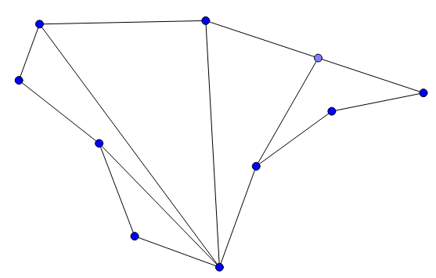
S

Shortest path maps

This section defines the shortest path map, which is a representation of all shortest paths from a source vertex s to points inside P. The shortest path map partitions the interior of P into triangular regions, each with a dis- tinguished vertex called the apex. The regions are chosen such that the shortest path from s to a point u passes through the apex of the region containing u.

To produce the shortest path map from the shortest path tree, we partition each funnel into regions by extending each edge on the side of a funnel until it hits the base of the funnel. Each resulting region is triangular; the base of the region is a subset of the funnel base, and the apex of the region is the triangle vertex opposite the base.
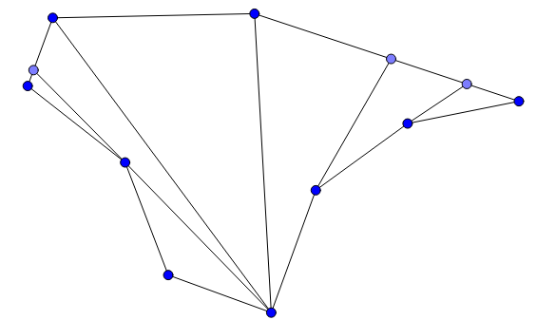
S

Design

SPT(v):Shortest Path Tree of vertex v
SPM(v):Shortest Path Map of vertex v
SP(a,b):Shortest Path from a to b
Polygon P is given as a counterclockwise sequence of vertices v₁ , v₂ , . . . , v_{2n} . We can apply algorithm to find shortest path tree for each vertex v _{i} and from that we can deduce what all vertices are visible from it(ones that are direct descendents of v_{i} ). And so union of all visibile segments from SPT(v₁), SPT(v ₂ )......SPT (v_{n}) will give us visibility graph in O(n²) time, as the algo of Guibas take O(n) time for individual SPT. Now we see an algo by Hershberger that computes this union in O(E) time, where E is the number of edges in the visibility graph of P .The reason is, set of all shortest paths has more structure than the set of single-edge paths. Once we have found the set of all shortest paths from one vertex, we can exploit the structure to find similar sets for the other vertices efficiently.
Following lemma shows the structure that we require to reduce the complexity:
For every vertex u of P , the parents of u in SPT ( v_{i} ) and SPT (_{vi+1} ) are different if and only if u is visible from some internal point of the edge v_{i}v_{i+1}.

Proof: Obervation: u is visible from an internal point on segment v_{i,} v_{i+1} only when both SP(v_{i} , u ) and SP (v_{i+1} , u ) cannot intersect the segment u vj (except at u ).Which means, all vertices in SP (v_{i} , u ) must lie on the c-wise boundary from v_{i} to u. Hence, the parent of u in SPT (v_{i} ) belongs to boundary of(u , v_{i} ). Similarly, all vertices in SP (v_{i+1} , u), including the parent of u in SP T (v_{i+1} ), belong to boundary of (v_{i+1} , u ). Therefore, the parents of u in SP T ( v_{i} ) and SP T (v_{i+1}) are different. For the other side(converse), assume u is not visible from any internal point of the edge v_{i,} v_{i+1} but the parents of vj in SP T ( v_{i} ) and SP T ( v_{i+1} ) are different. Let say the parent of u in SP( v_{i} ,u) is A and B for sp(v_{i+1} ,u) then if we extend these lines uA and uB then they intersect the line v_{i,} v_{i+1} at two points and that portion is visible from u which contradict our assumption that u is not visible from u, which completes our proof.
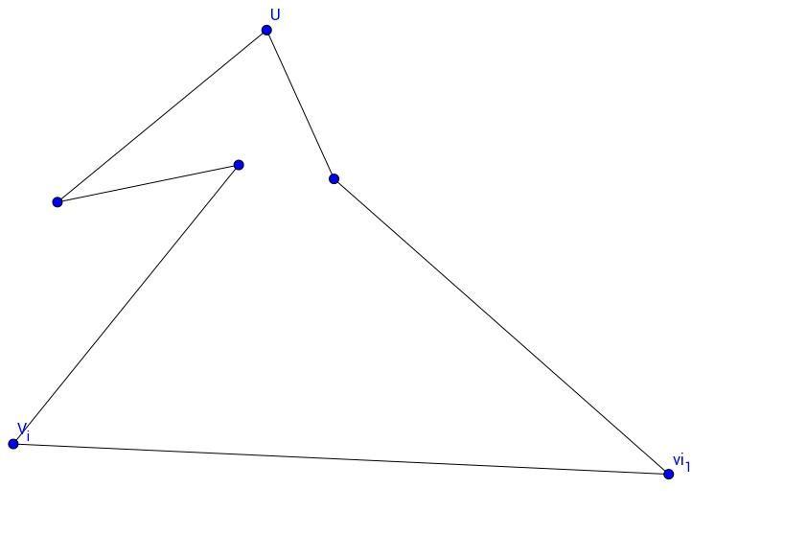
In outline, our algorithm is the following: We begin by representing all shortest paths from some arbitrary vertex v₁ in a structure called the shortest path map. From this structure we can find the vertices visible from v₁ in constant time apiece. Let v₂ be the vertex of P counter- clockwise of v₁. The shortest path map for v₂ is similar to that for v₁, and we can build one from the other in time proportional to the number of differences between them. We proceed around the boundary of P, constructing the shortest path map of each vertex from that belonging to its clockwise neighbor. At each step we obtain all visibility edges from the current vertex.

Steps to construct visibility Graph:

Input: polygonal vertices in counterclockwise ordering
Output: Visibility graph G
Initialisation: First we find SPT(v₁) using Guibas algorithm in O(n) time. Then construct SPM( v₁) from SPT(v₁) using following rule: If the funnels obtained from SPT(v₁) are not triangles then we draw extention edges from the apex of funnel to the base(AB) of funnel. These extention edges will divide funnel into triangles which gives us the SPM( v₁).We repeat this rule for all the funnels in SPT(v₁).
We keep two pointers x,y for vertices that will traverse the boundary of polgon. Initially, y is v_{i+1} . denotes the current vertex or point whose parent we are finding. If v_{i+1} is a convex vertex, x is initialized to the next counterclockwise vertex or point(created due to extention edge hitting on polygonal edge) of v_{i+1} on boundary(P ). Otherwise, x is initialized to the endpoint of the extension edge of SPM (v_{i} ) whose other endpoint is v_{i+1}, because this section of tree of SPT(v_{i} ) can be directly joined to SPT(v_{i+1}). Let z be the parent of x in SPT(v_{i}) if x is a vertex. If x is a point on some edge then xz forms an extention edge. Now we start :
For all vertices in Polygon P from v₁ ,v₂ ....v_{n} do:
Step 1. Search for vertex vk in SP (v_{i+1} , y), starting from y, such that xv_{k} is either the tangent from x to SP (v_{i+1}, y) or z lies to the left of ray xv_{k}
Step 2. IF z lies to the left of ray xv_{k} do:
a. Draw the cross-tangent uv_{m} between SP (v_{i} , z) and SP (v_{i+1} , v_{k}) where
u ∈ SP (v_{i} , z) and v_{m} ∈ SP (v_{i+1} , v_{k} )
b. Add uA as an extension edge of SPM(v_{i+1}), where A is the intersection point of v_{m}u and xy.
c. Connect the sub-tree of SP T (v_{i}) rooted at u (along with the map) to SP T (v_{i+1}) by assigning v_{m} as the parent of u (this is where we gained efficiency).
d. Extend each edge of SP (v_{m} , y) to xy to form the extension edges of SPM (v_{i+1})
e. Assign u to y

ELSE do:
Step 3. Extend each edge of SP (v_{k} , y) to xy to form extension edges of SP M ( v_{i+1})
Step 4. IF x is a point(created due to extention edge hitting on polygonal edge) or a leaf of SP T (v_{i} ) then assign v_{k} as the parent of x in SPT (v_{i+1}), assign x to y.
ELSE do:
Step 5. Add the extension edge xw of SPM (v_{i} ) as an extension edge of SPM (v_{i+1})
Step 6. Connect the sub-tree of SP T (v_{i} ) rooted at x (along with the map) to SP T
(v_{i+1}) by assigning v_{k} as the parent of x. Assign w to y(this is where we gained efficiency).
Step 7. Assign the next counterclockwise vertex or point of y on boundary(P ) to x. If x is
not v_{i} then goto Step 1.
Step 8. Remove from boundary(P ) the endpoints of the extension edges of SPM (v_{i} ) that are on the boundary of V (v_{i}v_{i+1} ) (they are unnecessary for other vertices in for loop)
Step 9. Add edges(v_{i} ,b) in visibility graph G, if v_{i} is root and b is any immediate child of v_{i} .

Complexity
As the source of the shortest path map moves around the boundary of Polygon, edges are added to and deleted from the current shortest path map. Shortest paths are combination of visibility edges and polygon edges, so we only need to account for the edges of the shortest path map that are not in the shortest path tree, and these are extention edges. These extension edges can be associated with a directed funnel edge( that is directed toward it) as they are just extentions of them. Funnel edges can be visible edges or polygon edges. Each directed edge has at most one extension edge. So as the source of the shortest path map moves around the perimeter of the polygon, each directed polygon edge or visibility edge is added to or deleted from the current shortest path map at most twice, one from pq side and other from qp side. There are 2n directed polygonal edges and 2m directed visibility edges. So each edge is added and deleted a constant number of times, which gives the desired bound on the running time O(m).

Conclusion

The optimal algorithm for computing visibility graphs for polygons with holes has complexity of O(nlogn + E)[Ghosh and Mount] but it is rather complex. So in this report we have seen two algorithm for computing visibility graphs and saw their application in finding shortest path from source to destination when polygonal obstacles are given. We have learnt new technique of angular sweep of given set of points and structure of polygon that helps us in reducing complexity of the task.

References

[1] J. Hershberger. Finding the visibility graph of a polygon in time proportional to its
size. Algorithmica
[2] E. Welzl. Constructing the visibility graph for n line segments in O(n 2 ) time. Infor-
mation Processing Letters,
[3] ttp://www.cs.kent.edu/~dragan/ST-Spring2016/visibility%20graphs.pdf
[4] David Mount Lecture Notes. www.cs.umd.edu/~mount/754/Lects/754lects.pdf

